SET 5
Q1. Data Structures & Algorithms (5 Marks)
Using AI assistance, write a Python script to implement Merge Sort.
Your script should:
1. Take a list of unsorted integers as input
2. Use Merge Sort to sort the list
3. Print each merge step (showing how subarrays are combined)
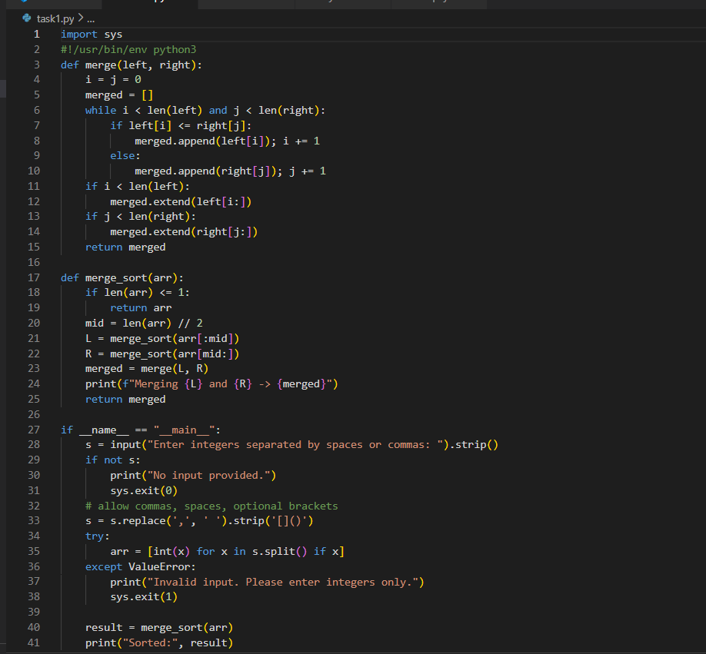
OUTPUT :
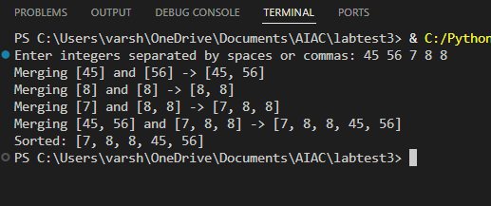
Q2. (Web Frontend – 5 Marks)
With AI assistance, generate a your personal Portfolio Website including
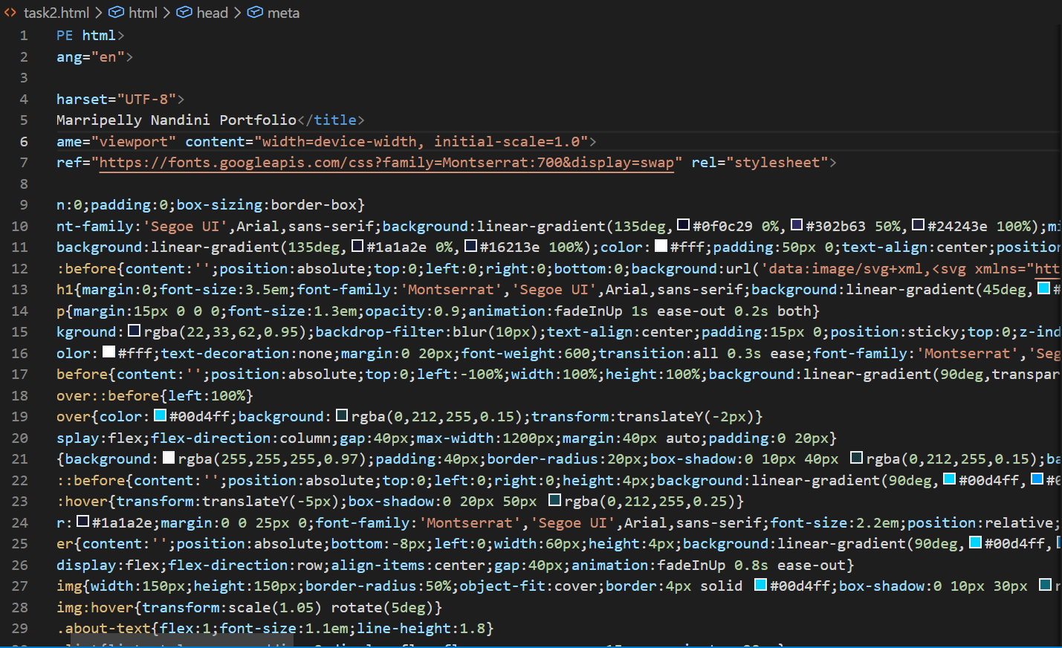
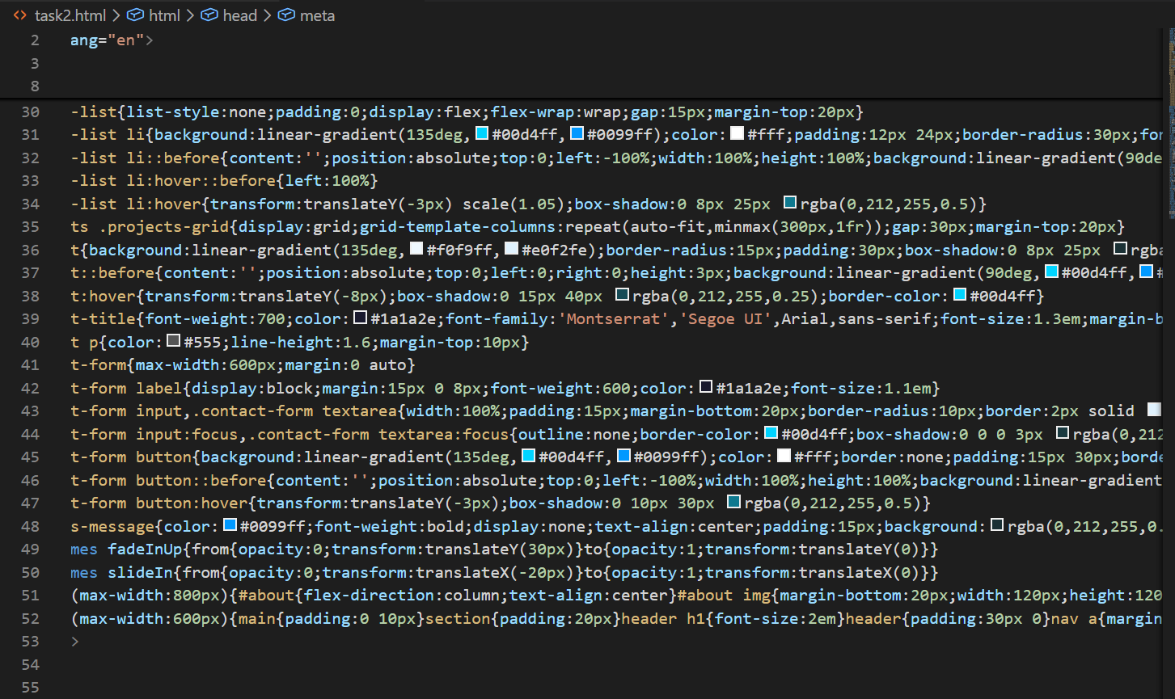
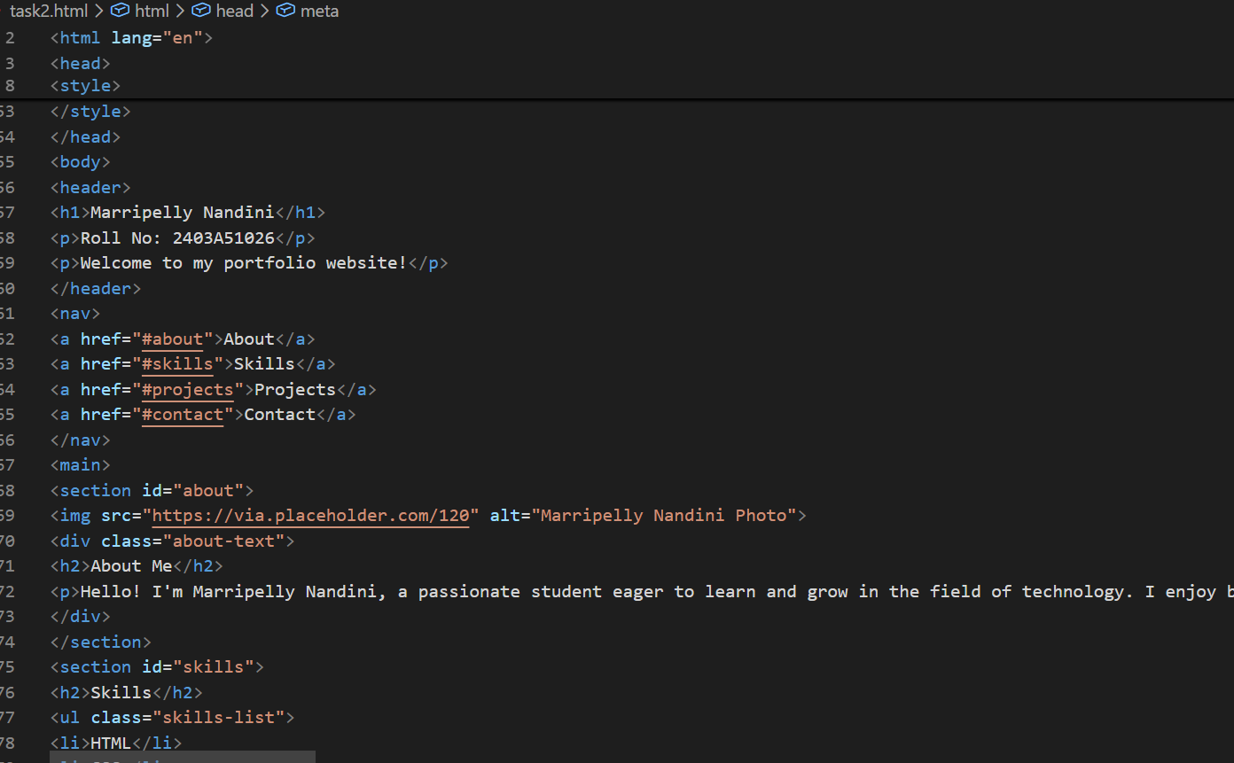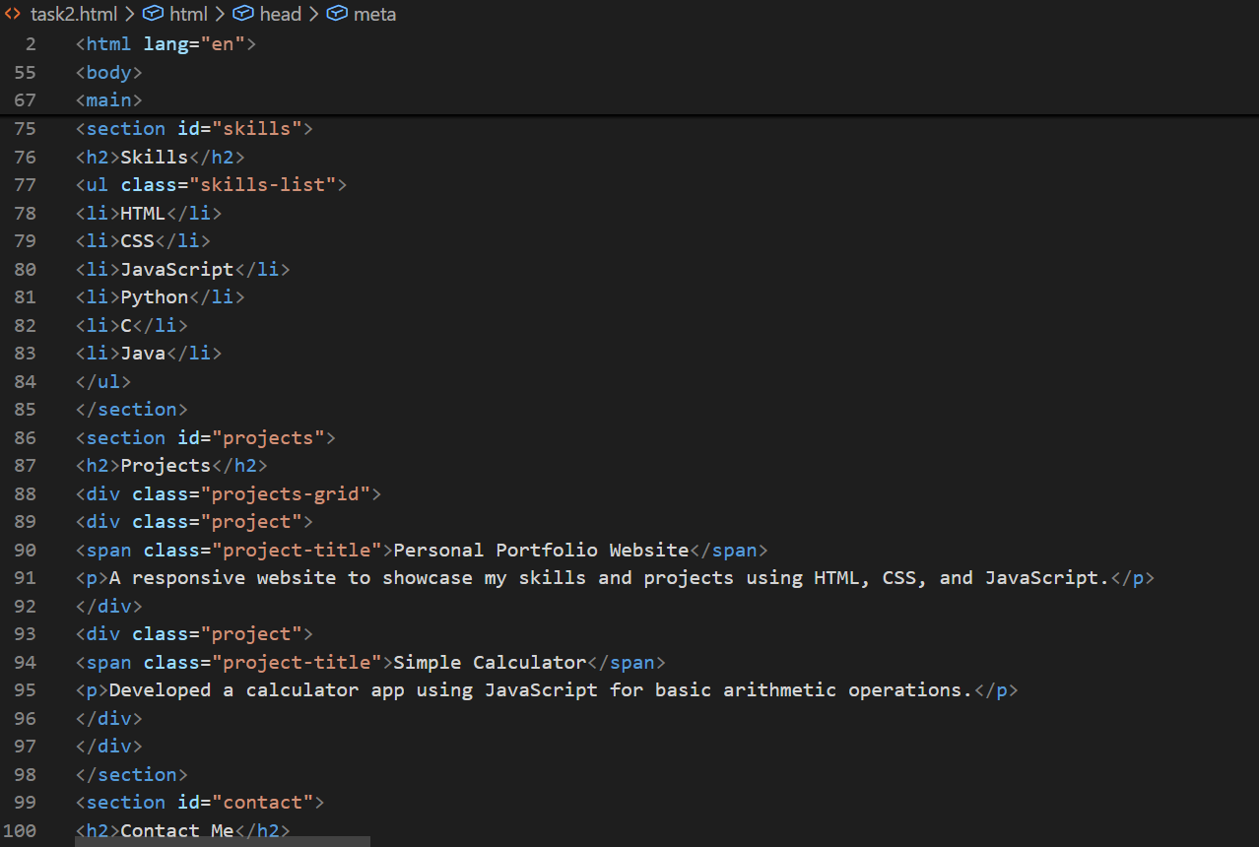
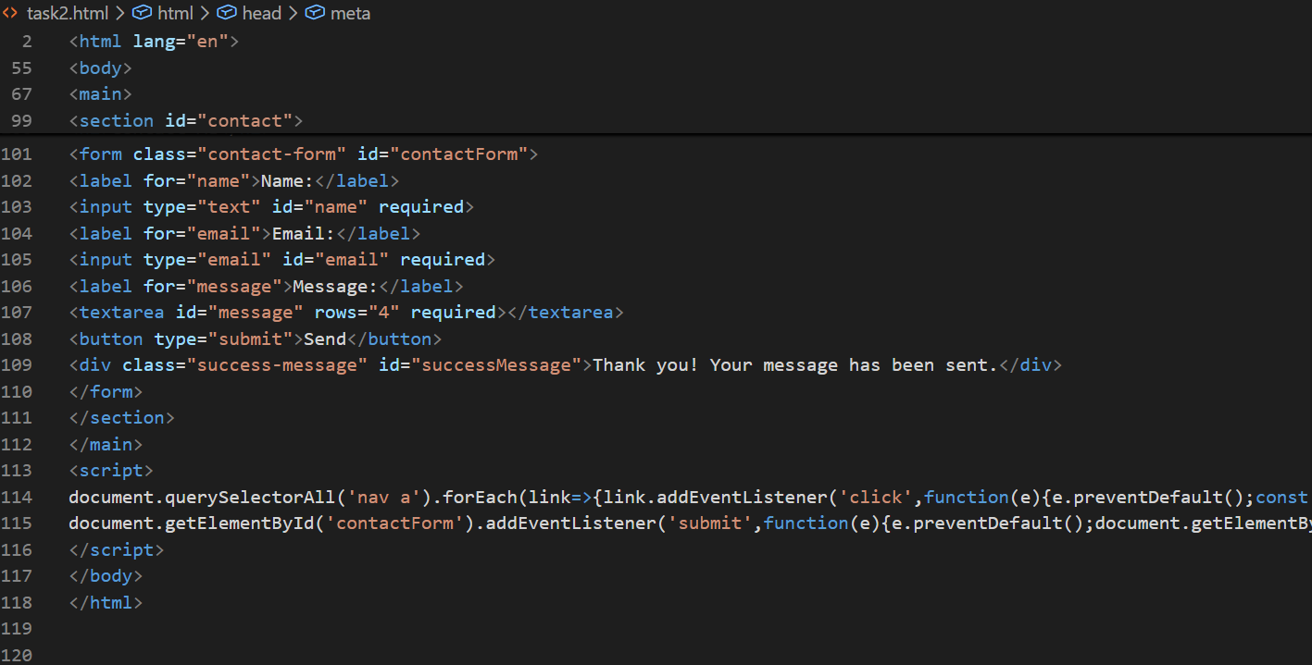
Output:

